INSTRUCTIONS TO APPLY ONLINE:

Go to: https://admissions.westerncape.gov.za

Click on Register
Read the terms and conditions, click yes and continue
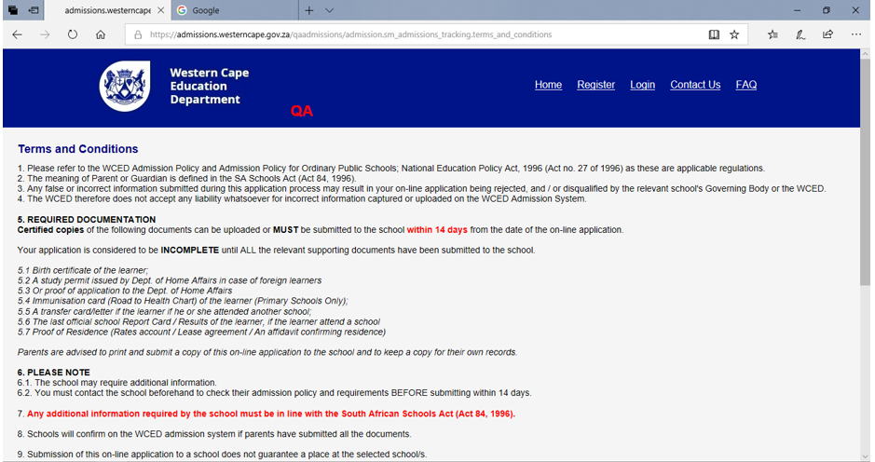
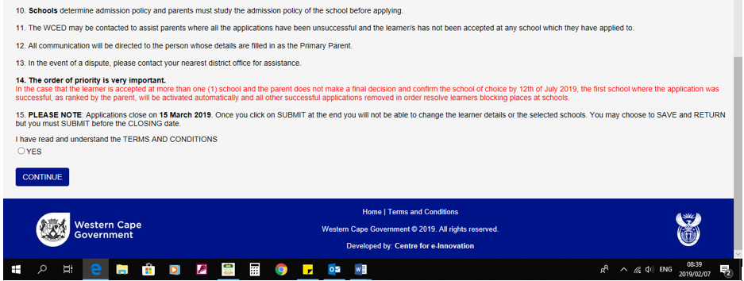

Complete all the fields and click on register

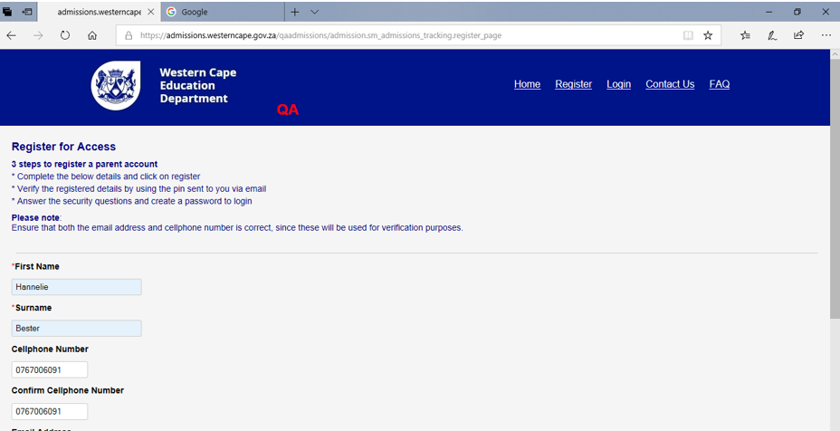
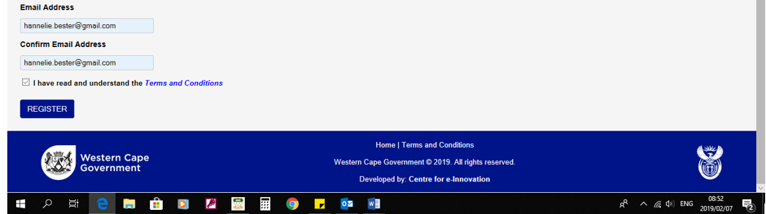

Fill in the onetime pin sent to you via sms or email.

Remember you have 15 minutes to fill it in the required field.

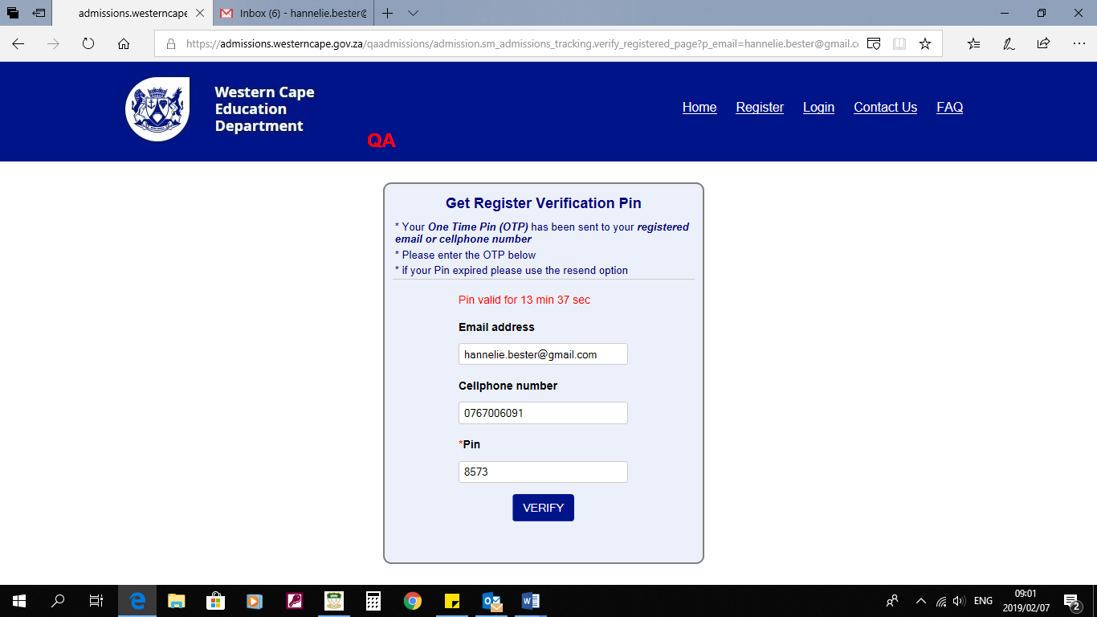
Click on verify

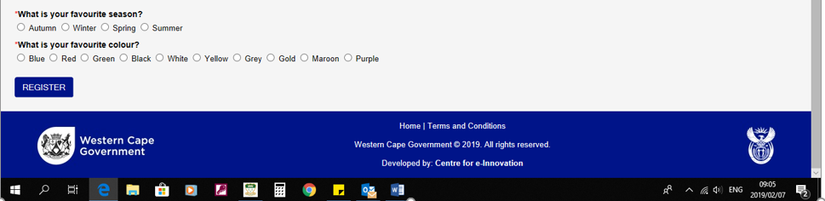
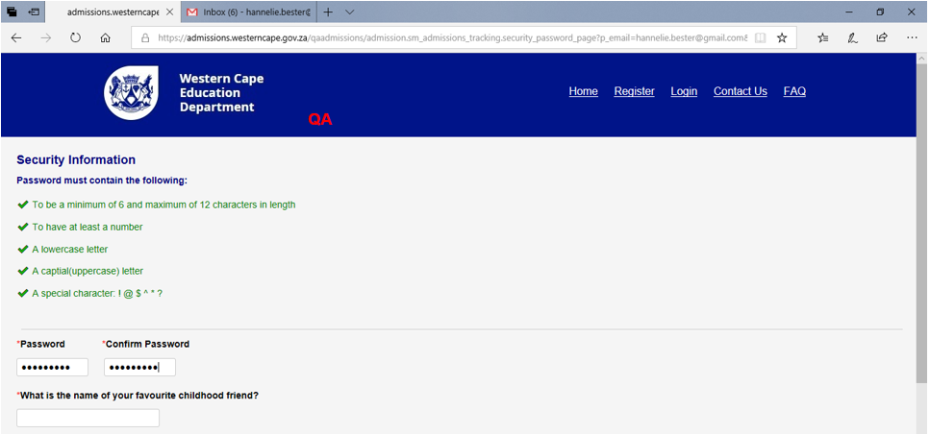
Fill in the required fields and click on register
Click on the link to login
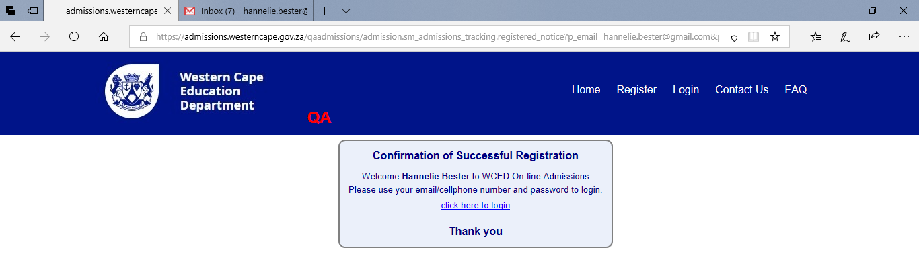
Login with cellphone number or email address
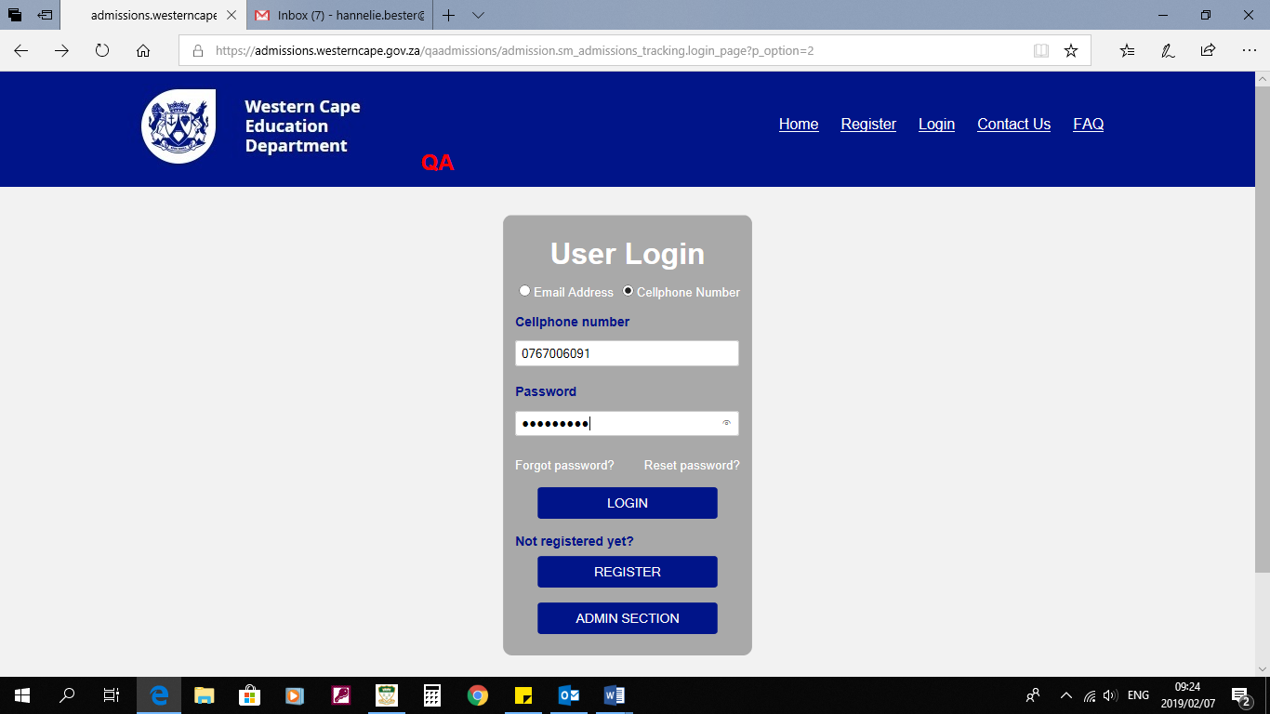

Fill in details of primary parent/guardian
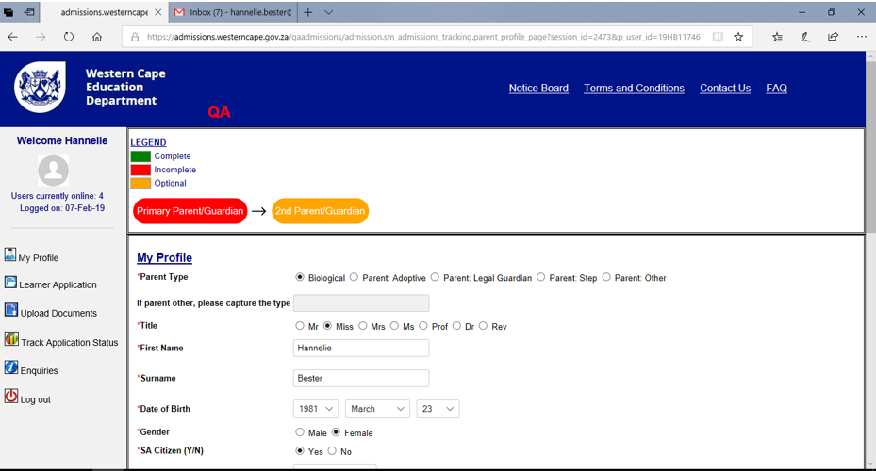
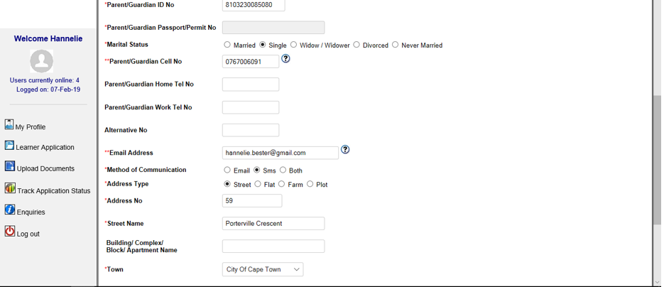
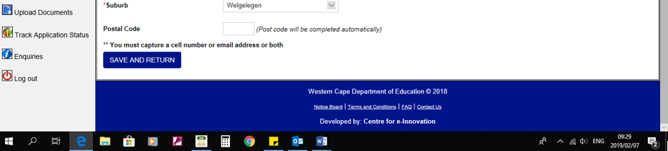
Click on second parent/guardian and complete the details if there is a second parent/guardian

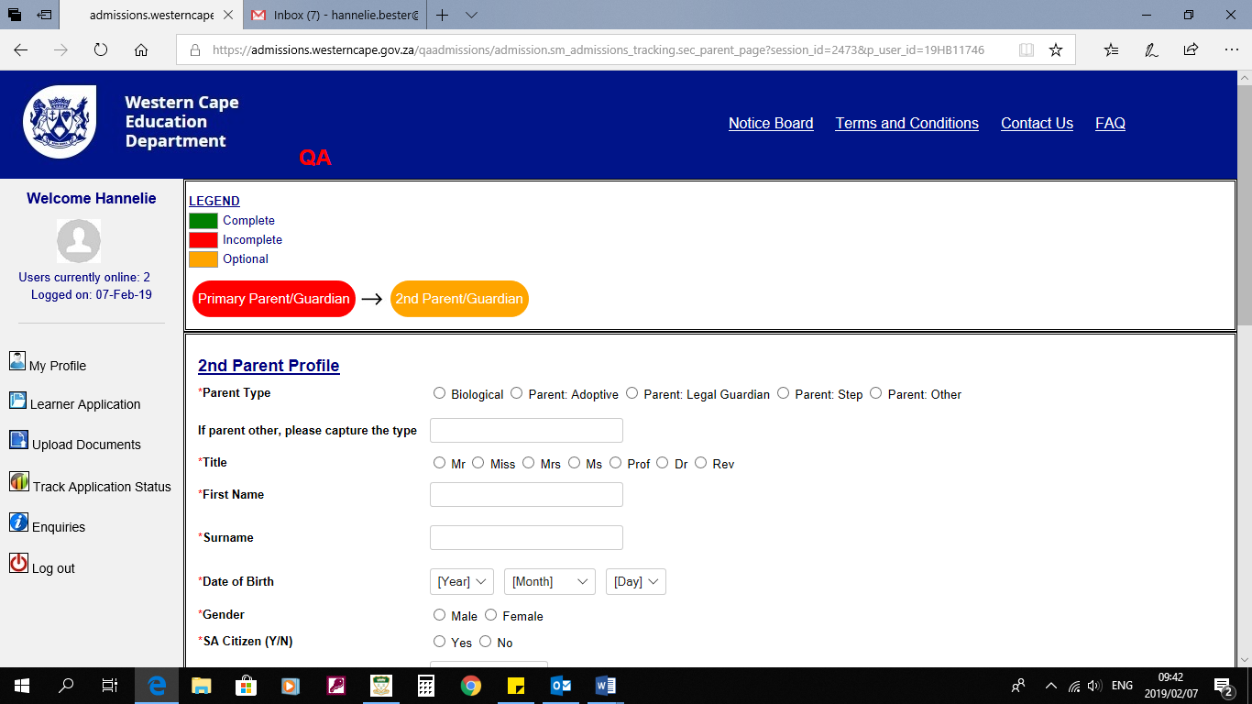
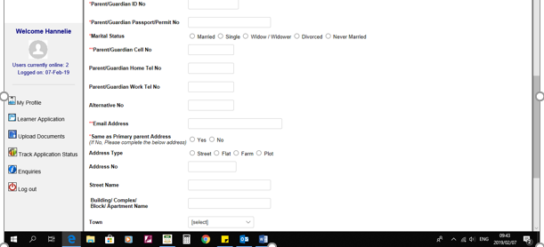
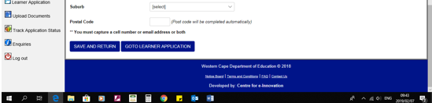

Click go to learner application

Applying for Grade 1 – Grade 7, use your child’s CEMIS nr or ID number to search for your child if your child is currently in a school in the Western Cape.

Applying for Grade R, click on new application.

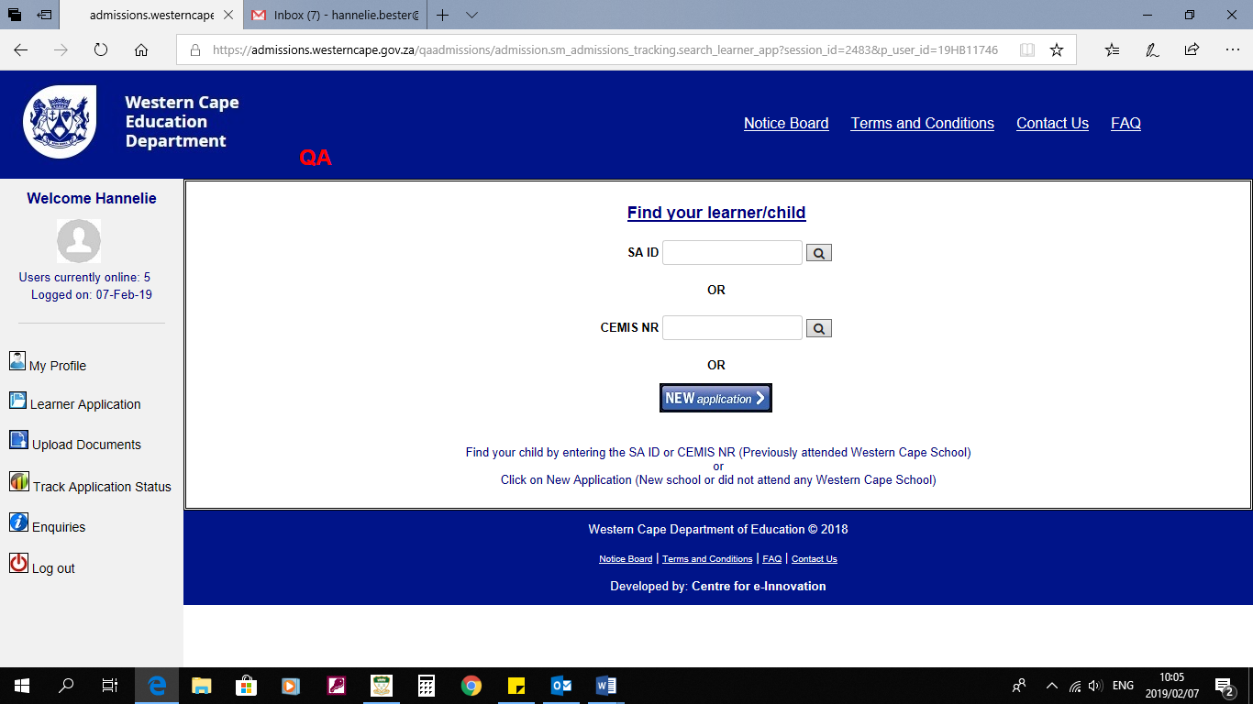
Applying for Grade R – Grade 7, but you relocated from a different provice and your child never attended a school in the Western Cape, click on new application.

Complete all the steps: Step 1 – Final Step submission

Step 1: Fill in learners details
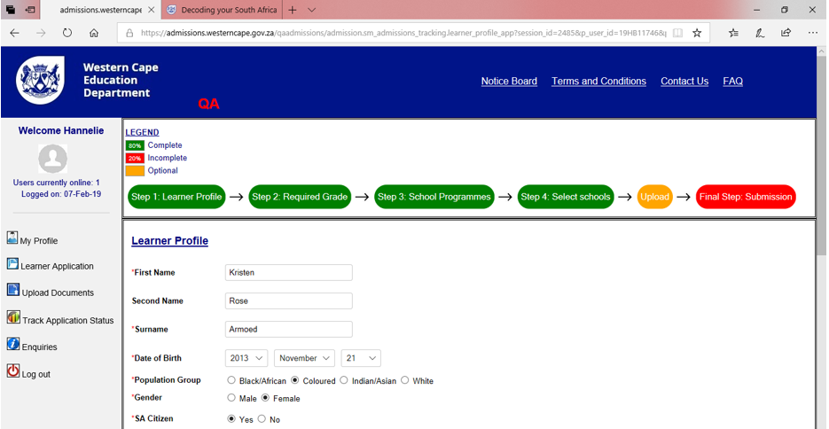
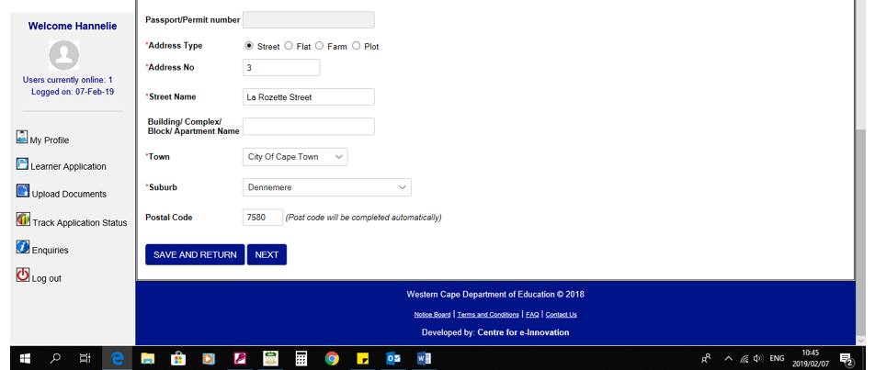

Step 2: Choose required grade, teaching language etc.

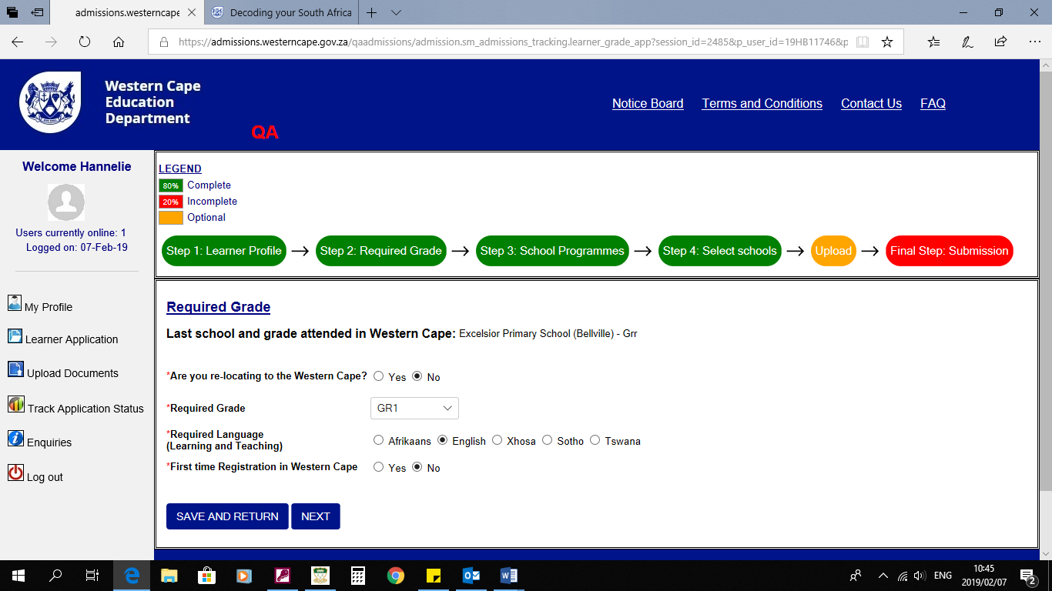

Step 3: Choose school programs, cultural programs etc.
Highlight the required program and use the arrows to move it over to the blank bock
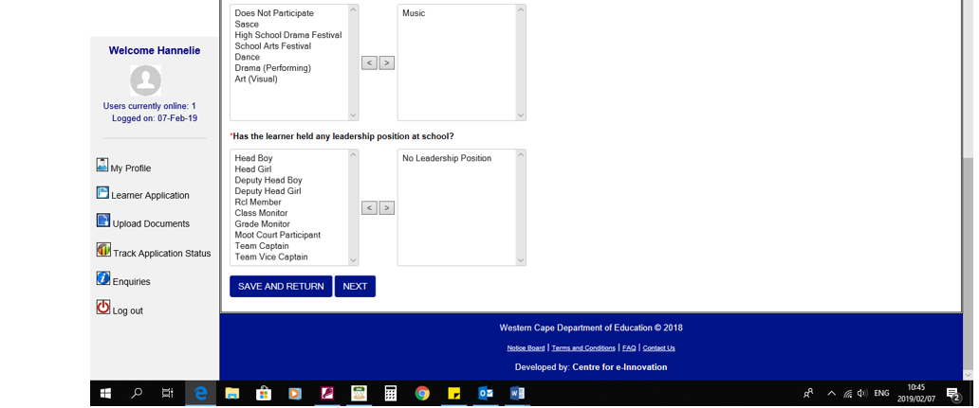
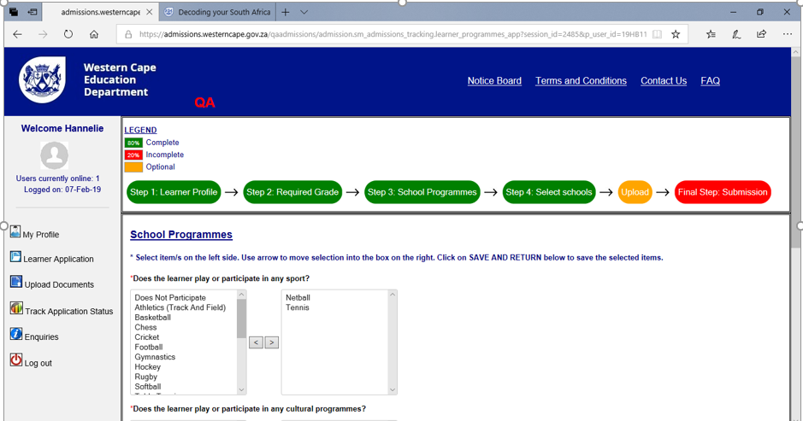

Step 4: Choose the schools you want to apply for. You can apply up to 10 schools.
You must apply at a minimum of 3 schools.
Highlight your choice of school and use the arrow to move it to the blank block.
Remember to rank you choice of schools from no 1 to 10
If a sibling already attends De Kuilen Primary, click on add sibling
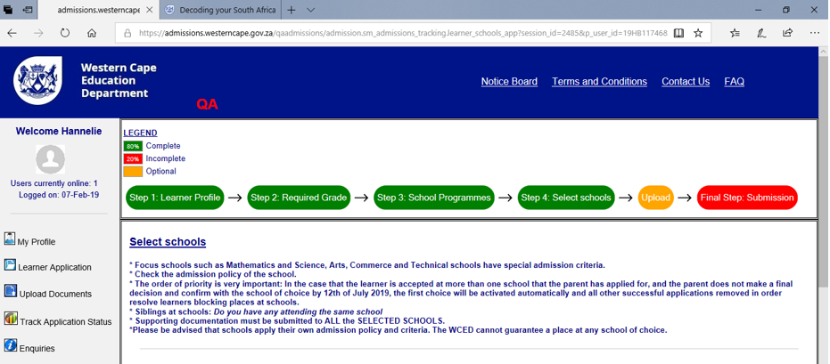
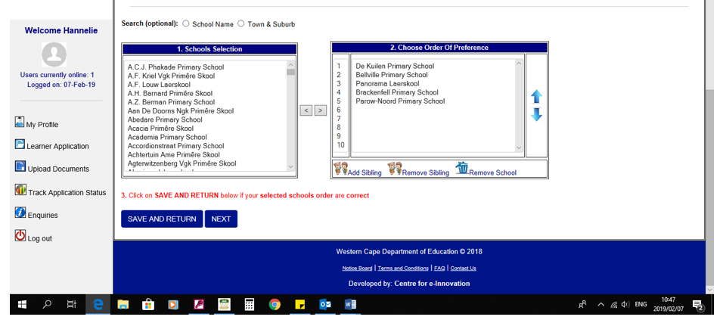

Step 5: Upload you documents.

Please read our admission policy to know what documents you must submit in 14 days at
De Kuilen Primary’s reception. You will have time until 15 April 2019 to submit the documents
If we do not receive all the documents by 15 April 2019 your application will not be processed and will be
unsuccessful.
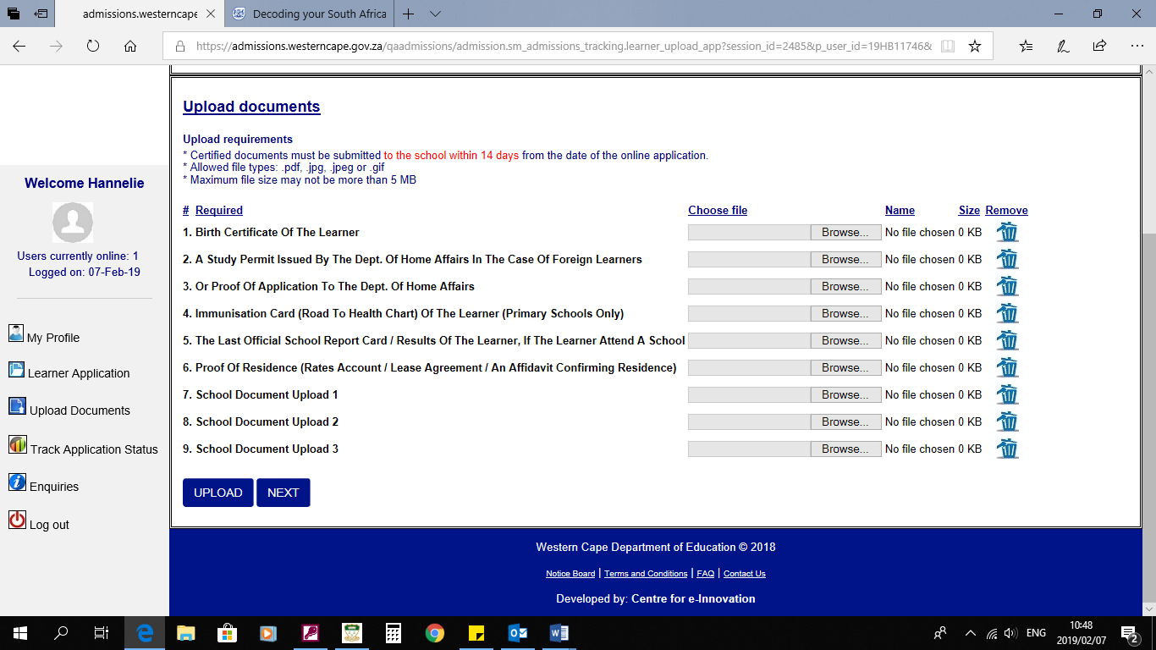

Step 6: Verify details. If you are satisfied click submit application form.
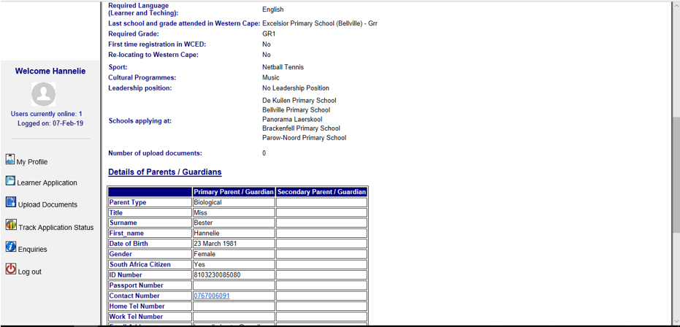
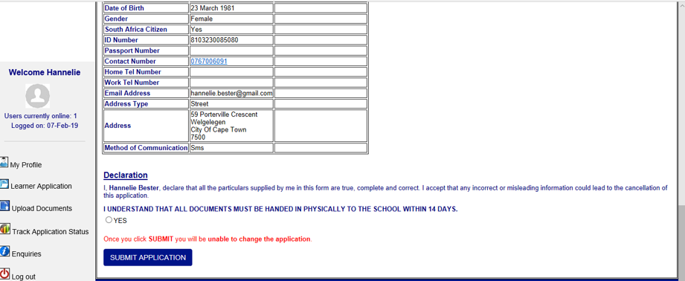
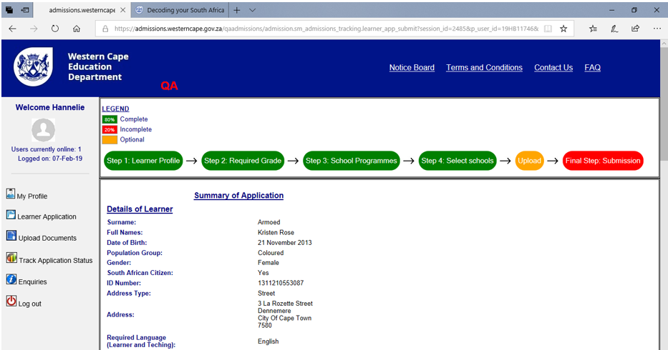

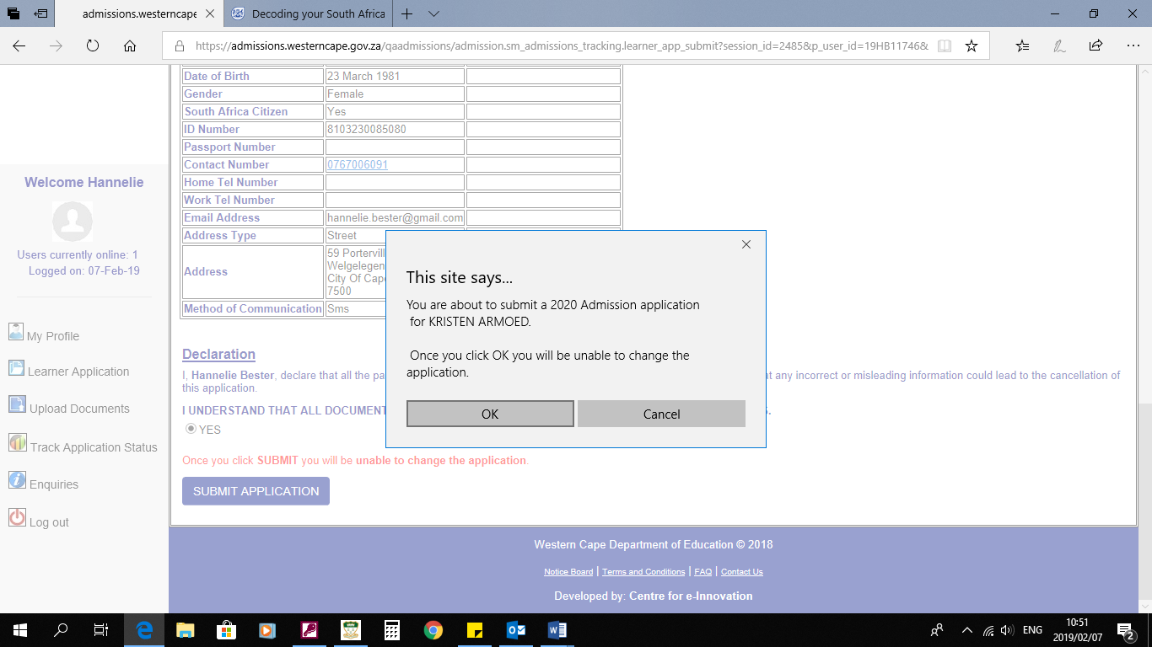
Click OK

Please remember to click on save and return regularly to save all information captured to avoid losing captured data due to time out session.

